**Sliding Window Pattern**

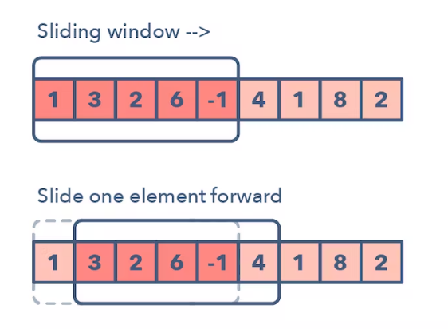

**Ways to Identify the pattern:**

* The problem input is a linear data structure such as a linked list, array, or string
* You’re asked to find the longest/shortest substring, subarray, or a desired value

**Common problems you use the sliding window pattern with:**

* Maximum sum subarray of size ‘K’ (easy)
* Longest substring with ‘K’ distinct characters (medium)
* String anagrams (hard)

**General Categories:**

* Fixed Window
* Variable length Window

**Broad Categories:**

* Fixed length
* Variable length with fixed length HashMap as the length modifying criteria
* Variable length with length modifying criteria of matching all the characters from HashMap with a sliding window in the given string
* Variable length with length modifying criteria of matching all the words from the given list with a sliding window in the given string

**Strategies to Solve the Problem:**

* Identify Fixed or Variable length Window.
* Identify the Criteria for which the length will get modified for variable length.